## 16-3第四章 胡天翊

P234二、程序练习.2。

#include<iostream>

using namespace std;

class student

{

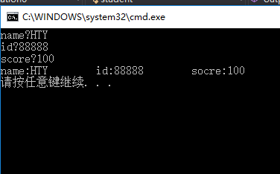public:

void input(student &stu)

{

cout << "name?";

cin >> stu.name;

cout << "id?";

cin >> stu.id;

cout << "score?";

cin >> stu.score;

}

void output(student &stu)

{

cout << "name:" << stu.name << "\tid:" << stu.id << "\tsocre:" << stu.score << endl;

}

private:

char name[20];

unsigned int id;

double score;

};

int main()

{

student s = {};

s.input(s);

s.output(s);

}

P242二、程序设计.1。

#include<iostream>

using namespace std;

class Book

{

public:

void initialize(char *name, double Price, int Number);

void display(Book &book);

void borrow();

void restore();

private:

char bookname[20];

double price;

unsigned int number;

};

int main()

{

Book hoh;

char Switch = 'y', choice = '\0';

hoh.initialize("house of holes", 9.99, 3);

while (Switch=='y')

{

cout << "借书（b）/还书（r）" << endl;

cin >> choice;

switch (choice)

{

case 'b':hoh.borrow(); break;

case 'r':hoh.restore();

default:break;

}

cout << " " <<"是否继续运行，是（y）/否（n）" << endl;

cin >> Switch;

}

}

void Book::display(Book &book)

{

cout << "\t图书名称：" << book.bookname << "\t图书价格" << book.price << "\t库存数量：" << book.number << endl;

}

void Book::borrow()

{

if (number == 0) { cout << "无库存！不能借阅" << " "; }

else --number;

cout << "库存数量：" << number;

}

void Book::restore()

{

++number;

cout << "库存数量：" << number;

}

void Book::initialize(char *name, double Price, int Number)

{

strcpy_s(bookname, name);

price = Price;

number = Number;

cout << "图书名称：" << bookname << "\t图书价格" << price << "\t库存数量：" << number << endl;

}

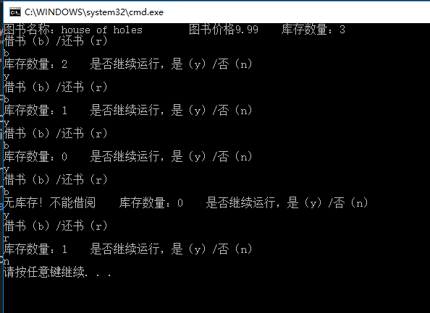

P242二、程序设计.3。

#include<iostream>

using namespace std;

class student

{

public:

void scoretotalcount(double s);

double sum();

double average();

private:

static double total;

static int count;

};

double student::total = 0;

int student::count = 0;

int main()

{

student class3;

char Switch = 'n';

int temp;

while (Switch=='n')

{

cout << "请输入学生成绩";

cin >> temp;

class3.scoretotalcount(temp);

cout << " " <<"是否完成，是（y）/否（n）";

cin >> Switch;

}

cout << "学生总分：" << class3.sum() << endl;

cout << "平均分数：" << class3.average() << endl;

}

void student::scoretotalcount(double s)

{

count++;

total += s;

}

double student::sum()

{

return total;

}

double student::average()

{

return total / (double)(count);

}

